**Name: Tanay Parikh**

**E-Mail id:Tanay.parikh2017@vitbhopal.ac.in**

**University Roll no: 17BCE10101**

**Role-Applied: Quality Assurance(QA)**

**Q1. You need to write as many test cases as possible for a simple software program which computes the eligible discount for a customer. Try to describe all possible scenarios in a tabular format. Do not worry about ‘login’ kind of test cases, and just focus on how you will validate discount calculation. These are the rules.**

**If the customer is new, and they are willing to sign up for a new loyalty card, they get a 15% discount on all their purchases on the day. Second if they are an existing customer and hold a loyalty card, they get a 10% discount. Third, if they have a discount coupon, they will get 20% off which cannot be used with the new customer discount but can be used with loyalty card discount. Discount amounts are added, if applicable.**

**Solution:**

**STEP-1**

It is divided into Six categories:

1. New Customers With coupon
2. New Customers without a coupon
3. Old Customers With loyalty cards and no coupons.
4. Old Customers With loyalty cards and with coupons.
5. Old Customers Without loyalty cards and no coupons.
6. Old Customers Without loyalty cards with no coupons.

**STEP-2**

**Decision Table:**

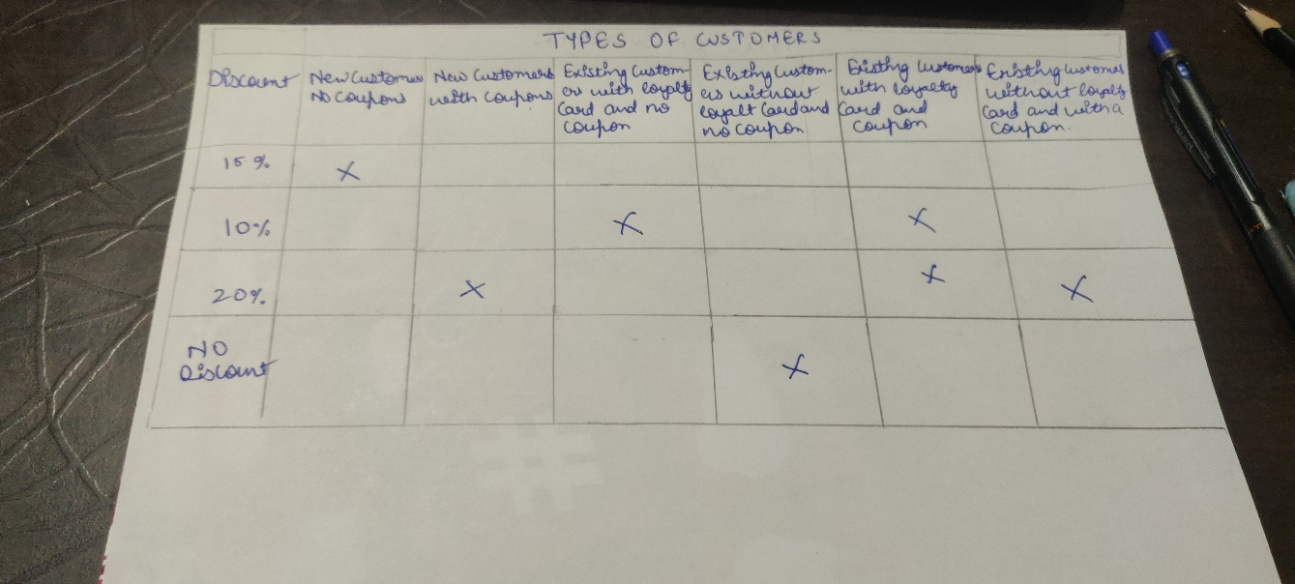

**Step 3: Pick A user and test every category in it**

Now from each category, you can pick one value and test to see if the correct amount of discount is applied.  
So now, you will need 6 customers or 6 test cases to test the case completely and more efficiently.

Also, keep in mind that, it is not important to get the solution a 100% right.

**Q2. The following appeared as part of an article in the business section of a local newspaper:**

**“Ronnie’s Auto Repair Shop commenced business four months ago at the location formerly occupied by the Jenny’s Beauty Parlour. Ronnie’s Auto must be doing well at this location, because it intends to open a big shop in an adjacent town. Jenny’s, on the other hand, has seen a lower volume of business in its first year at its new location compared to the prior year at its former location. Jenny’s definitely erred in shifting to its new location; its former location is a better site.”**

**Discuss how well reasoned you find this argument. In your discussion be sure to analyse the line of reasoning and the use of evidence in the argument. For example, you may need to consider what questionable assumptions underlie the thinking and what alternative explanations or counterexamples might weaken the conclusion. You can also discuss what sort of evidence would strengthen or refute the argument, what changes in the argument would make it more logically sound, and what, if anything, would help you better evaluate its conclusion.**

***Solution:*** In This Argument we can come to Conclusions that:

1) Primarily, it’s nowhere mentioned that Ronnie’s business is an old business so it might be possible that it is a new venture.

Whereas, In case of Jenny’s beauty parlour she already had a shop in past , and the past records can be comparable with the present one. So we can see how Past records can affect. Therefore ,We cannot compare the success of the two business as One might be the new one and other one could be the old business.

2) Secondly, the nature of Business is different, Auto parts repair shop is all time business whereas Jenny’s beauty parlour is Seasonal business which happens mostly in Wedding season , Festivals, and other functions. So we can say that Both the business are completely different and can’t be compared . We can see that As parlour was already opened before at other place so we can Compare the profits of past and present and in the case of Auto-parts There is no mentioning of any past shops, So any amount of profit would result into good going of business.

3) As we can also conclude that parlour was in the old location for a long time, So their permanent customers were developed. New Locations takes time to develop new customers and people and it takes time to gain relations. Whereas auto-parts shop is a urgent need. So even if not much relations are maintained it won’t be a much problem-Still it also requires relation but not as much in Parlour.

As there are new reasons as well ,Therefore ,It’s too soon to draw any conclusion In parlour case that whether the new location is better or not in terms of parlour also that Ronnie , is expanding because he is doing well in business is base less there can be other reasons well behind expansion.

***Question 3) How will you test a wireless mouse? What are the different things you will test and check before you can say that it is a good quality wireless mouse?***

**Solution**: First, We will check Wireless Mouse Specification Details

**1)Specification Details :**

* Check The company logo-It is placed in a specific location or not.
* Check Whether it has a hallmark of specification or not.
* Check The USB of a Wireless mouse.
* Check The specifications mentioned on a packing.
* Check if the device Connections are platform independent.
* Check whether it has a label of proper Warranty and guarantee period.

**2) Interaction Test:**

* Check If the USB is detected by your Operating Systems(Microsoft , Linux, MAX).
* Check whether it requires any other Specifications.
* Check Whether it is not creating any discrepancy.
* Check Whether the pointer is visible or not.
* Check whether it has any Hardware or software problem.
* Check Whether the Pointer is visible after connecting the USB.
* Check for the basic functionality whether it is connected to your PC or not.

**3)Software Tests:**

* Verify that Right button and Left Button.
* Verify the scroll button by scrolling up and down.
* Verify the Buttons while performing certain options.
* Check by double clicking - opening of files and folders.
* Check Whether it is Dragging folders or files or not.

As, we have checked all the probabilities of finding a wireless mouse faulty ,So it’s good to buy and most importantly it satisfied all the above cases. So by these testing and checking we can say that it’s good to buy and use.